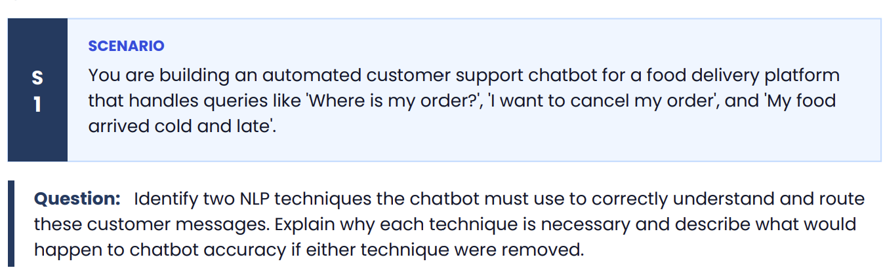
The chatbot must use the following two NLP techniques:
1. Intent Recognition (Intent Classification)
Purpose:
Intent recognition identifies what the customer wants to do. It classifies the user's message into predefined intents such as:
- "Where is my order?" → Track Order
- "I want to cancel my order." → Cancel Order
- "My food arrived cold and late." → Complaint
Why it is necessary:
The chatbot must understand the customer's goal so it can route the request to the correct service or workflow. Without intent recognition, the chatbot would not know whether to provide tracking information, process a cancellation, or register a complaint.
If removed:
The chatbot would frequently misunderstand customer requests, route them to the wrong department, or provide irrelevant responses, significantly reducing accuracy and customer satisfaction.

2. Sentiment Analysis
Purpose:
Sentiment analysis determines the customer's emotional tone, such as positive, neutral, or negative.
Example:
- "My food arrived cold and late." → Negative sentiment
- "Thanks for the quick delivery!" → Positive sentiment
Why it is necessary:
It helps the chatbot identify frustrated or dissatisfied customers and prioritize or escalate their issues to a human support agent when needed. This improves the overall customer experience.
If removed:
The chatbot would treat all messages the same, failing to recognize urgent or unhappy customers. Complaints may not receive appropriate attention, leading to poorer service quality and lower customer satisfaction.

Conclusion
Both techniques work together to improve chatbot performance:
- Intent Recognition ensures the chatbot understands what the customer wants.
- Sentiment Analysis helps it understand how the customer feels.
Removing either technique would reduce the chatbot's ability to understand customer requests accurately and provide appropriate, timely responses.
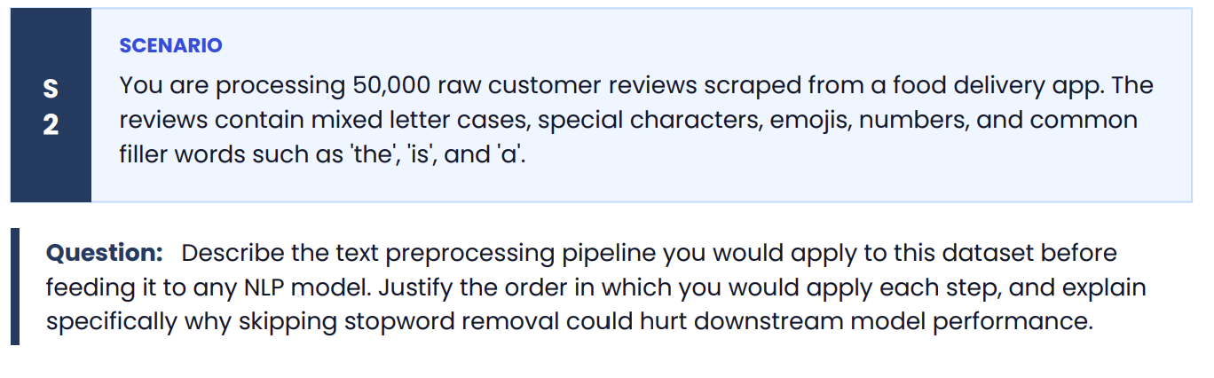
Text Preprocessing Pipeline for 50,000 Customer Reviews
Before training or using any NLP model, the raw text should be cleaned and standardized. The preprocessing pipeline is:
1. Convert Text to Lowercase
Example:
- "Food Was GREAT!" → "food was great!"
Why first?
Converting everything to lowercase ensures that words like Food, FOOD, and food are treated as the same word, reducing duplicate vocabulary.

2. Remove Special Characters, Punctuation, Emojis, and Numbers
Example:
- "Great!!! 😊 #1" → "Great"
Why second?
These characters usually do not contribute to the meaning of the review (unless emojis are intentionally used for sentiment analysis). Removing them makes the text cleaner and reduces noise.

3. Tokenization
Split the cleaned text into individual words (tokens).
Example:
- "food arrived late" → ["food", "arrived", "late"]
Why now?
Most later preprocessing steps, such as stopword removal and stemming, work on individual words rather than entire sentences.

4. Remove Stopwords
Remove common words such as:
- the
- is
- a
- and
- of
Example:
- ["the", "food", "is", "good"]
- → ["food", "good"]
Why here?
Once the text is tokenized, stopwords can be identified and removed easily.

5. Stemming or Lemmatization
Reduce words to their base form.
Examples:
- Stemming: "delivering" → "deliver"
- Lemmatization: "better" → "good", "running" → "run"
Why last?
After removing unnecessary words, only meaningful words are normalized, reducing vocabulary size while preserving meaning.

Why This Order?
The order is important because each step prepares the data for the next:
- Lowercase → Standardizes text.
- Remove noise → Eliminates unnecessary characters.
- Tokenization → Splits text into words.
- Stopword removal → Removes unimportant words.
- Stemming/Lemmatization → Normalizes the remaining meaningful words.
Changing the order can make preprocessing less effective. For example, stopword removal is difficult before tokenization because the text has not yet been split into individual words.

Why Skipping Stopword Removal Hurts Performance
If stopwords are not removed:
- Larger vocabulary: Frequent words like the, is, and a unnecessarily increase the number of unique tokens.
- More noise: These words carry little semantic meaning and can distract the model from important words such as late, cold, refund, or excellent.
- Higher computational cost: The model processes more tokens, increasing memory usage and training time.
- Reduced accuracy: Important keywords become less influential because common filler words dominate the text representation, especially in models like Bag-of-Words and TF-IDF.
Example
Original review:
"The food is very cold and the delivery is late."
After preprocessing:
["food", "cold", "delivery", "late"]
The cleaned version focuses on the important information, making it easier for the NLP model to identify that the review is a delivery complaint with negative sentiment.
Conclusion
A proper preprocessing pipeline—lowercasing → noise removal → tokenization → stopword removal → stemming/lemmatization—produces clean, standardized text that improves model accuracy, reduces computational cost, and enables the NLP model to focus on the most meaningful information in customer reviews.
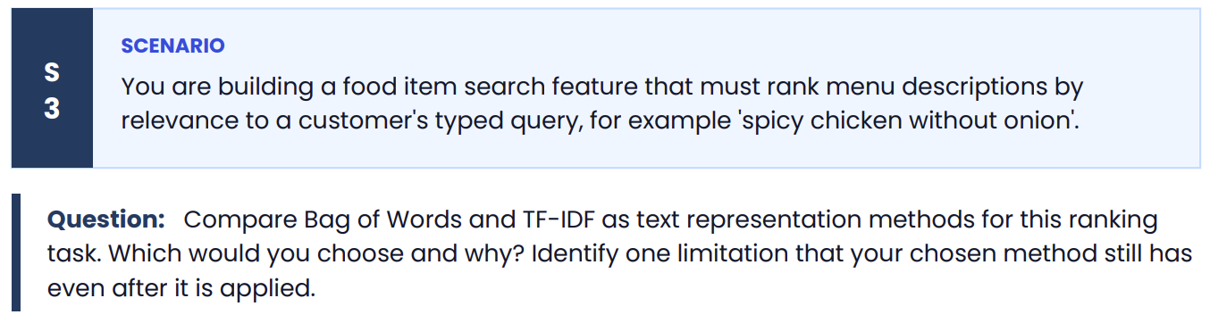
Comparison of Bag of Words (BoW) and TF-IDF
Feature | Bag of Words (BoW) | TF-IDF
Concept | Counts how many times each word appears in a document. | Weighs words based on their frequency in a document and how rare they are across all documents.
Importance of Common Words | Treats all words equally, even common words like "food" or "restaurant." | Reduces the weight of very common words and gives higher importance to distinctive words.
Ranking Quality | Less effective because frequent words may dominate the results. | More effective because important keywords receive higher weights.
Computational Cost | Simple and fast. | Slightly more complex but still efficient.

Which Method Would I Choose?
I would choose TF-IDF for this food search task.
Why?
For a query such as:
"spicy chicken without onion"
TF-IDF gives higher importance to meaningful keywords such as spicy, chicken, and onion, while reducing the influence of common words that appear in many menu descriptions.
This leads to:
- More accurate search results.
- Better ranking of relevant menu items.
- Improved retrieval performance compared to Bag of Words.

Why Bag of Words Is Less Suitable
Bag of Words only counts word occurrences.
For example:
Menu 1: "Spicy chicken burger with onion"
Menu 2: "Chicken meal with fries and drink"
Since BoW only considers word counts, common words like chicken may dominate, making it harder to distinguish which menu item is actually more relevant to the query.

Limitation of TF-IDF
Even after applying TF-IDF, it has an important limitation:
It does not understand context or word meaning.
For example:
Query:
"spicy chicken without onion"
Menu Description:
"Spicy chicken served with onion."
TF-IDF recognizes the words spicy, chicken, and onion, but it cannot understand that "without onion" means the customer wants onion excluded. It ignores the semantic meaning and word relationships.
Similarly, TF-IDF cannot recognize synonyms such as:
- hot ≈ spicy
- poultry ≈ chicken
because it treats each word as an independent feature.

Conclusion
For ranking menu descriptions, TF-IDF is a better choice than Bag of Words because it assigns greater importance to informative keywords and reduces the influence of common words, resulting in more relevant search rankings. However, TF-IDF still cannot understand context, word order, or semantic meaning, so it may struggle with queries involving negation (e.g., "without onion") or synonyms.
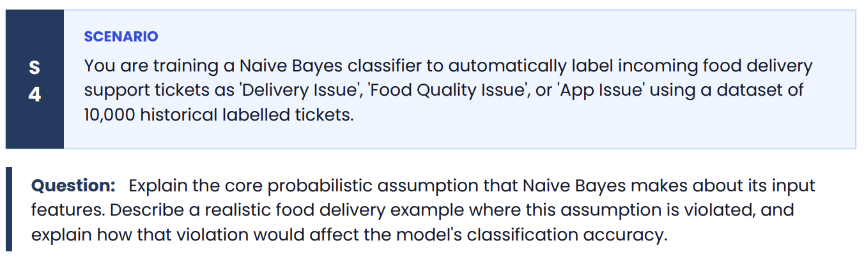
Naive Bayes Core Assumption
The Naive Bayes classifier assumes that all input features (words in a text) are conditionally independent given the class label.
In other words, once the class is known (e.g., Delivery Issue, Food Quality Issue, or App Issue), the occurrence of one word does not affect the probability of another word occurring.
For example, if a ticket belongs to the Delivery Issue class, Naive Bayes assumes that words like late, delivery, and driver appear independently of each other.

Example Where the Assumption Is Violated
Consider the support ticket:
"My food arrived cold and late."
Here, the words cold and late are not independent.
- Late delivery often causes food to become cold.
- These words frequently appear together in food delivery complaints.
Another example:
"App crashed during payment."
The words app, crashed, and payment are closely related and commonly occur together in App Issue tickets.
These examples violate Naive Bayes' independence assumption because the presence of one word increases the likelihood of the others appearing.

Effect on Classification Accuracy
When the independence assumption is violated:
- Naive Bayes treats correlated words as if they provide completely separate pieces of evidence.
- This can overestimate or underestimate the probability of a class.
- As a result, the classifier may assign the wrong label.
Example
Ticket:
"My food arrived cold and late."
Correct label:
Food Quality Issue (or possibly both Food Quality and Delivery Issue)
Because cold and late are highly correlated, Naive Bayes counts them as independent evidence. This may give excessive weight to one class (e.g., Delivery Issue) and ignore the fact that the complaint is also about food quality.
This can lead to misclassification or lower confidence in the correct class.

Conclusion
The core assumption of Naive Bayes is that features (words) are conditionally independent given the class. In real food delivery support tickets, words are often correlated—for example, "cold" and "late" or "app" and "payment" frequently occur together. These dependencies violate the assumption, causing Naive Bayes to estimate class probabilities less accurately and potentially reduce classification accuracy, although it often still performs well because of its simplicity and efficiency.
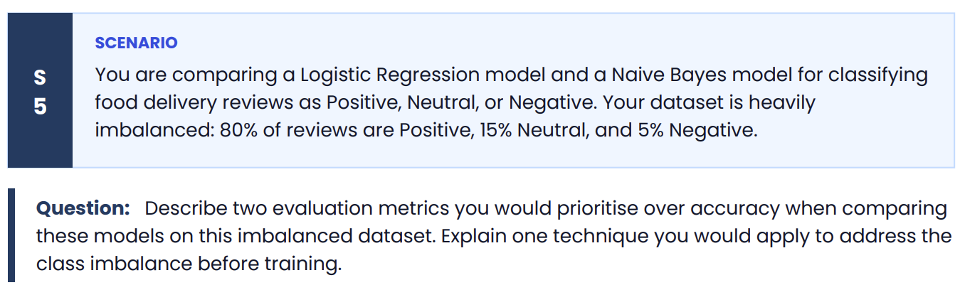
Evaluation Metrics for an Imbalanced Dataset
The dataset contains:
- Positive: 80%
- Neutral: 15%
- Negative: 5%
Since the classes are highly imbalanced, accuracy is not a reliable metric. For example, a model that predicts every review as Positive would achieve 80% accuracy, yet completely fail to identify Neutral and Negative reviews.
1. Precision
Definition:
Precision measures how many of the reviews predicted as a particular class are actually correct.
Formula:
Precision = True Positives / (True Positives + False Positives)
Why prioritize it?
For the Negative class, high precision means that when the model predicts a review is negative, it is usually correct. This helps avoid falsely flagging positive or neutral reviews as negative.

2. Recall (Sensitivity)
Definition:
Recall measures how many actual reviews of a class are correctly identified.
Formula:
Recall = True Positives / (True Positives + False Negatives)
Why prioritize it?
For the minority Negative class, high recall ensures that most unhappy customer reviews are detected instead of being incorrectly classified as Positive or Neutral. Missing negative reviews could prevent the company from addressing customer complaints promptly.
Note: In practice, many practitioners also report the F1-score, which combines Precision and Recall into a single metric and is especially useful for imbalanced classification.

Technique to Address Class Imbalance
Oversampling the Minority Classes (e.g., SMOTE)
Before training, I would apply oversampling to increase the number of Neutral and Negative reviews. A common technique is SMOTE (Synthetic Minority Over-sampling Technique), which creates synthetic samples for the minority classes instead of simply duplicating existing ones.
Why use it?
- Balances the class distribution.
- Gives the model enough examples to learn the characteristics of minority classes.
- Reduces bias toward the majority Positive class.
- Improves the model's ability to correctly classify Neutral and Negative reviews.

Conclusion
For this imbalanced sentiment classification task, I would prioritize Precision and Recall over accuracy because they provide a better assessment of performance on minority classes. To address the imbalance before training, I would use SMOTE-based oversampling so that Logistic Regression and Naive Bayes can learn all three sentiment classes more effectively, leading to improved detection of Neutral and Negative reviews.
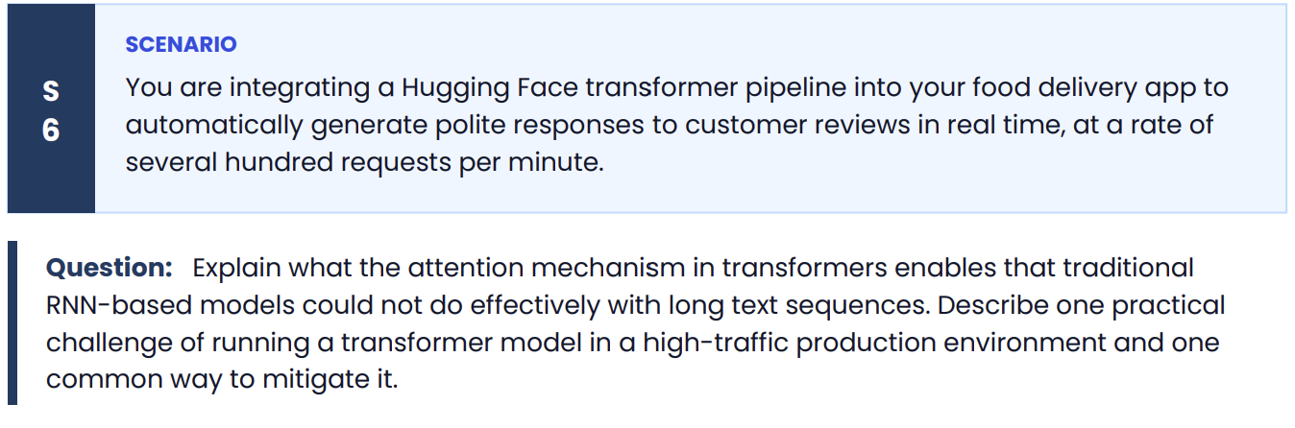
Attention Mechanism in Transformers
The attention mechanism allows a transformer to focus on the most relevant words in the entire input sequence when processing each word.
For example, consider the customer review:
"The delivery was delayed by an hour, but the support team quickly resolved the issue and offered a refund."
The attention mechanism enables the model to understand relationships between words such as delivery, delayed, support, and refund, even though they are far apart in the sentence.
Why is this better than RNNs?
Traditional RNN-based models process text one word at a time in sequence. As the sequence becomes longer:
- Earlier information can be forgotten (vanishing gradient problem).
- It becomes difficult to capture long-range dependencies.
- Processing is sequential, making it slower.
In contrast, transformers with attention:
- Can directly relate any word to any other word in the sequence.
- Capture long-distance context much more effectively.
- Process tokens in parallel, making training significantly faster.
This results in better understanding of long customer reviews and more accurate, context-aware responses.

Practical Challenge in a High-Traffic Production Environment
A major challenge is high computational cost and inference latency.
If the application receives hundreds of requests per minute, running a large transformer model for every request can:
- Increase response time.
- Consume significant CPU/GPU memory.
- Increase infrastructure costs.
- Reduce scalability during peak traffic.

Common Mitigation Technique
One common solution is using a smaller or optimized model.
Examples include:
- DistilBERT
- TinyBERT
- Quantized transformer models
- ONNX or TensorRT optimized models
These models:
- Require less memory.
- Produce responses much faster.
- Maintain most of the accuracy of larger models.
- Allow the application to handle more requests per second.
Additional production techniques include:
- Batch processing multiple requests.
- Model caching.
- GPU acceleration.
- Auto-scaling inference servers.

Conclusion
The attention mechanism enables transformers to capture long-range relationships between words and process entire sequences efficiently, overcoming the limitations of traditional RNNs on long text. In a high-traffic production environment, the main challenge is the high computational cost and latency of transformer inference. A common mitigation is to deploy an optimized lightweight transformer model (such as DistilBERT or a quantized model), which reduces response time and resource usage while maintaining good performance.

